CURRICULUM-VITAE

NITIN SRIVASTAV
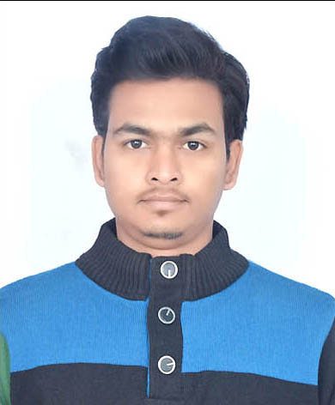
PERMANENT ADDRESS
Moh Katoratal, Kashipur
Distt. U.S. Nagar (UK), Pin- 244713
CONTACT NO:91-9837605322
8909953650
Email id: nitinpoly89@gmail.com

Carrier Objective
My career is to honestly, sincerely & build a symbolic relationship with your organization. My efforts will be completed by career growth, higher degree of responsibility by providing myself as a valuable asset.

Education Qualification
- 10TH Passed from Uttarakhand Board, Kashipur in 2009.
- 12TH Passed from Uttarakhand Board, Kashipur in 2011.
- Polytechnic Diploma in “Civil Engineering” with 68% from Govt Polytechnic Kashipur in 2014.
- B.A (Private) Appearing from Kumaun University Nainital.
- I.T.I (MES) Electrical Basic & Computer Fundamental.
- Autocad from Ideal Institute kashipur.

Training Skil
- 1Month Training- D.Bali Developers & Builders KASHIPUR” in Civil Department.
- 2 Week Training- P.W.D KASHIPUR.

Working Experience

1 Year Apprentice with Irrigation Department, Kashipur…

Strengths

- Always keen to learn new things, punctual, & hardworking.
- Ambitious & flexible by attitude and can mould myself as per new work.

Hobbies
- Listening to Music
- Playing chess

Personal Detail

Name : Nitin Srivastav
Date of Birth : 30 june 1994
Father’s Name : Sh.Girish Chandra Srivastav
Gender : Male
Nationality : Indian
Marital Status : Unmarried
Language : Hindi/English

Declaration

I, hereby declare that the information furnished above is true to the best of my knowledge.

DATE-
PLACE - KASHIPUR (Nitin Srivastav)

